9/30 | 10/1 | 10/2 | 10/3 | 10/4
Shepard’s Pie | Chicken Fajita | Bacon Cheddar | Sloppy Joe | French Bread PIZZA
w/ potato crust | Onions, Peppers | Burger | Oven Baked Fries | Cheese or Roni
Golden Carrots | & Cheese | Maple Baked Beans | Rainbow Tray | Garden Salad
Rainbow Tray | Flour Tortilla | Rainbow Tray | w/ Fruit & Veggies | Rainbow Tray
w/ Fruit & Veggies | Rainbow Tray | w/ Fruit & Veggies |  | w/ Fruit & Veggies
 | w/ Fruit & Veggies
Alt. Popcorn Chicken | Alt. Popcorn Chicken | Alt. Popcorn Chicken | Alt. Popcorn Chicken | Alt. Popcorn Chicken
10/7 | 10/8 | 10/9 | 10/10 | 10/11
Mini Corn Dogs | Cheese Quesadilla | French Toast Sticks | Beef-a- Roni!
Maple Baked Beans | Zesty Tom Salsa | Chicken Sausage | Garlic Knot
Rainbow Tray | Sweet Steamed Corn | Hash Browns | Garden Salad
w/ Fruit & Veggies | Rainbow Tray | Rainbow Tray | Rainbow Tray
 | w/ Fruit & Veggies | w/ Fruit & Veggies | w/ Fruit & Veggies
Alt. Chicken Patty | Alt. Chicken Patty | Alt. Chicken Patty | Alt. Chicken Patty
10/14 | 10/15 | 10/16 | 10/17 | 10/18
 | Beef & Bean Chili | Rodeo Burger | General Tso’s Chicken | French Bread PIZZA
 | Topped w/ Cheese | BBQ Sauce & Ched | Steamed Broccoli | Cheese or Roni
 | Tortilla Chips | Onion Ring | Seasoned Brown Rice | Cucumber Wheels
 | Golden Corn | Baked Beans | Fortune Cookie | Rainbow Tray
 | Rainbow Tray | Rainbow Tray | Rainbow Tray | w/ Fruit & Veggies
 | w/ Fruit & Veggies | w/ Fruit & Veggies | w/ Fruit & Veggies
 | Alt. Cheesy Bread | Alt. Cheesy Bread | Alt. Cheesy Bread | Alt. Cheesy Bread
10/21 | 10/22 | 10/23 | 10/24 | 10/25
Toasted Cheese | Crunchy Beef Tacos | Chicken & Waffles | Chicken Parm Roll | Fried Dough PIZZA
Potato Chips | Cheese, Lettuce, | Sweet Potato Fries | Garden Salad | w/ Sauce & Cheese
Crisp Baby Carrots | & Salsa | Rainbow Tray | Rainbow Tray | It. Green Bean Salad
w/ Ranch Dip | Cheesy Refried Beans | w/ Fruit & Veggies | w/ Fruit & Veggies | Rainbow Tray
Rainbow Tray | Rainbow Tray |  |  | w/ Fruit & Veggies
w/ Fruit & Veggies | w/ Fruit & Veggies
Alt. All Beef Hot Dog | Alt. All Beef Hot Dog | Alt. All Beef Hot Dog | Alt. All Beef Hot Dog | Alt. All Beef Hot Dog
10/28 | 10/29 | 10/30 | 10/31
Crispy Chicken | Mexican Rice Bowl | Cheese Burger | BBQ Chicken
Tenders w/ Dip | Seasoned Chicken, | Lettuce & Tomato | Cilantro Lime Brown
Golden Corn, Bread | Black Beans, Salsa | Cowboy Beans | Rice
Stick, Rainbow Tray | Cheese & Brown Rice | Potato Chips | Steamed Broccoli
w/ Fruit & Veggies | Rainbow Tray | Rainbow Tray | Rainbow Tray
It’s National | w/ Fruit & Veggies | w/ Fruit & Veggies | w/ Fruit & Veggies
Chocolate Day!
Alt. Meatball Grinder | Alt. Meatball Grinder | Alt. Meatball Grinder | Alt. Meatball Grinder
Hampton Elementary School
Breakfast & Lunch Menu
OCTOBER 2019
Breakfast and lunch are available to all students for free!
Staff/Visitor Lunches: $4.00
Fresh Fruits and Veggies served Every Day!
Be sure to Check out our Rainbow Tray!!

FOOD NEWS!
Welcome!
…to the 2019-2020 school year! We hope you all had a great summer!

- October is National Farm to School Month! Join us and thousands of schools, early care and education sites, farms, communities and organizations across the country as we celebrate food education, school gardens and lunch trays filled with healthy, local ingredients!
- October 9th is National Stop Bullying Day, which is referred to by some as “Unity Day” is observed annually on the second Wednesday in October. This annual designation is designed to bring awareness of the need to stand up against and put an end to bullying.

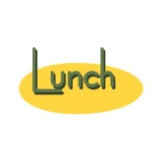
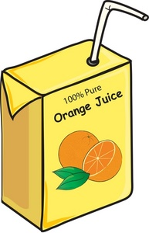
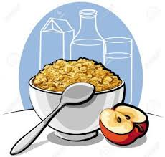
A complete breakfast includes; Whole Grain based Entrée, Milk, Fruit and/or 100% Fruit Juice.
Reduced Sugar Whole Grain Cereals are available in addition to the daily offering.

Daily Breakfast Menu:
Cereal, Cheese Stick or Yogurt, Fruit, 100% Juice & Milk are offered Daily
Monday: WG Muffin (Assorted Flavors)
Tuesday: Breakfast Burrito
Wednesday: French Toast
Thursday: Bagel-Egg & Cheese
Friday: Assorted Breakfast Pastry

A meal is considered complete is 3 out of 5 food groups are present on the tray, including a serving of fruit.

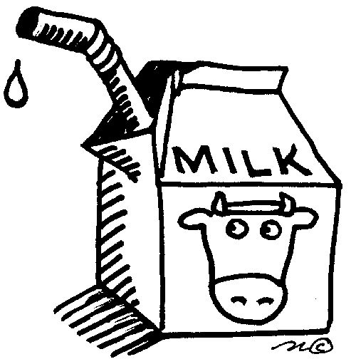
Lunch choices include: Fat Free or 1% Regular Milk and fat-free chocolate milk
Alternate lunches are available daily by request only and include all food group components:
• A nut butter* & jelly or nut butter & fluff
On whole wheat bread
*(Wowbutter, Peanut Butter)
• Salad with turkey, salad with cheese or salad with turkey & cheese (*EXCEPT *Salad Days)

What does a complete hot lunch include?
Grain, meat/meat alternate, vegetable, fruit & milk

Students are encouraged to select all 5 components!

This is an equal opportunity institution.

